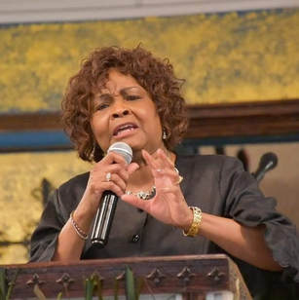
Donna Lindsey Robinson of North Little Rock, AR has been an evangelist for more than 30 years and has been blessed to speak at many churches and venues from Women’s Days to Music Events in several states and denominations across the continental United States and beyond. Her ministry is far-reaching and cross-cultural. Robinson has spent many years as a "go to" for ministries in need of support. She has consulted and acted as pastor to congregations. Her gift of speaking includes a very clear, "real" and concise message that comes straight from the Bible.
Mother Robinson is the Jurisdictional Supervisor for the Rehoboth Sint Maarten Jurisdiction, under the leadership of Bishop Robert G. Rudolph and District Missionary for the New Day District in the Arkansas Second Jurisdiction under the leadership of Bishop Frank Anderson,Jr. She is a member of The Worship Center Church of God in Christ in North Little Rock, AR. Elder Lloyd Allen is Senior Pastor. She serves there in many capacities at the Worship Center, including the Advisory and Mother's Boards. She oversees the Women's Ministries and works in administration. She is a capable leader who gets things done.
Robinson is a magnet to young ladies who need a role model, she offers support and care for many. Her ministry in this area is extensive. Her ability to show the love of Christ by "any means necessary" makes her a Spiritual Mother that is much needed in this day and time. Her desire to provide Hope for the Hurting is very evident in her ministry style. Her personal ministry called Hope for the Hurting, lends itself to that mission. Outside of her local church, Robinson has served the International Church of God in Christ as a member of the General Assembly Committee on Standards and Extensions. Formerly served the Arkansas' Second Jurisdiction COGIC as the State Evangelism Department's Elect Lady. She also served 17 years as the Arkansas Second Jurisdiction COGIC's Minister of Music. Mother Robinson also served as the Overseer of the Unity Church of God in Christ in Hot Springs, AR.
Mother Robinson is a graduate of Philander Smith College with Bachelor of Arts Degree in Sociology and has worked in social work in the protection of children and families. She is a graduate of Lee’s School of Cosmetology and spent 18 years as the owner of New Attitude Salon in North Little Rock. Her other studies include courses at the University of Arkansas (Fayetteville) and Jackson Theological Seminary. Evangelist Donna Robinson is the eldest daughter of Bishop and Madame D.L. Lindsey. Her family is completed as the wife of Larry, and proud mother and grandmother.
Donna Robinson can be contacted at dlindsey_robinson@yahoo.com or on Facebook and Instagram.

